**SQL Assessment Tasks:**

1. Create the “XXBCM_ORDER_MGT" table using the script - DB_Prequisite.sql

* Done

1. Based on the data provided implement a database schema with necessary tables, columns, data types and constraints. Create your tables in the database with appropriate naming convention. The tables should be appropriately normalized.

* Done, Schema BCM created

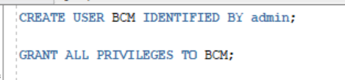

1. Develop a SQL procedure to trigger a migration process that will extract information from table "XXBCM_ORDER_MGT" and load them in tables that you created with proper data format. You are expected to create a database package with appropriate functions or procedures. All the database objects that you need to create shall be available on your working database environment and properly compiled.

* Package XXPO_MIGRATE_ORDER_MGT_PKG created and compiled
* Package Name:
  + Spec: XXPO_MIGRATE_ORDER_MGT_PKG.pks
  + Body: XXPO_MIGRATE_ORDER_MGT_PKG.pkb
* Package executed:

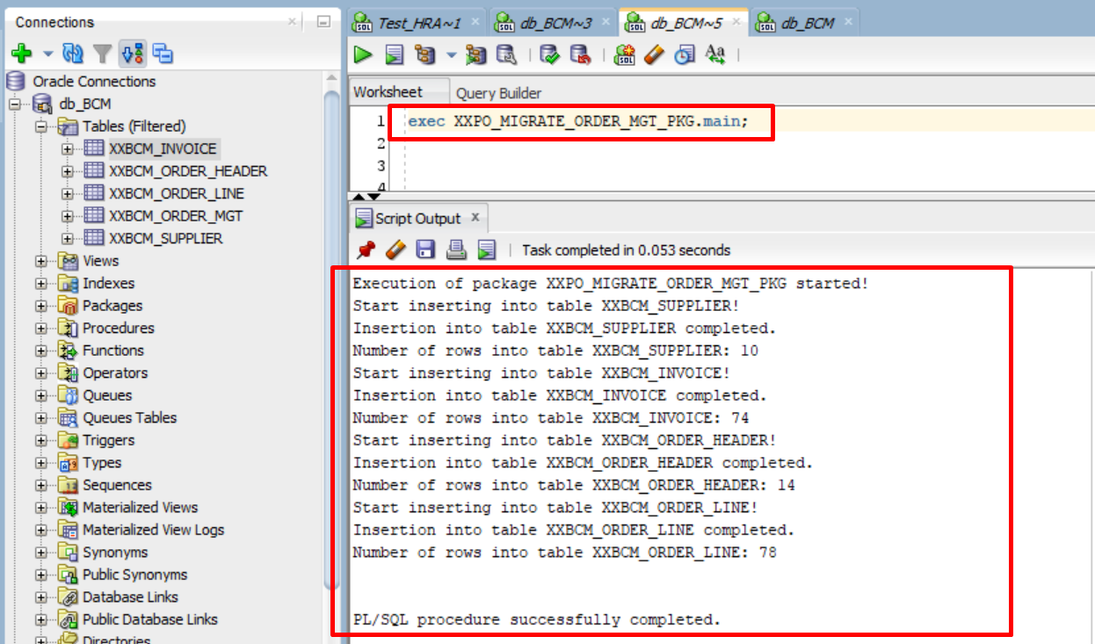

1. The owner wishes to have a report displaying a summary of Orders with their corresponding list of ***distinct*** ***invoices and their total amount*** to be able to reconcile his orders and payments. The report shall contain the details as per table below ordered by latest *Order Date* on top. Implement a Stored Procedure or Function to return the required information.

|  |  |
| --- | --- |
| **Column Name** | **Specifications** |
| Order Reference | Exclude prefix PO and return only numeric value, e.g. PO001 shall return value 1. |
| Order Period | Period based on *Order Date*. Example of expected format “JAN-17”. |
| Supplier Name | First character in each word to uppercase and the rest to lowercase. |
| Order Total Amount | Format “99,999,990.00”. |
| Order Status | As per record. |
| Invoice Reference | As per record. |
| Invoice Total Amount | Format “99,999,990.00”. |
| Action | Return the following value based on the invoice statuses.  If all invoice statuses are Paid, display “OK”.  If any of the invoice statuses is Pending, display “To follow up”.  If any of the invoice Statuses is Blank, display “To verify”. |

* Script file name: ques4.sql
  + Contains function get_action to return the current action based on invoice status
  + Select statement to return the expected data
* Execution of select statement

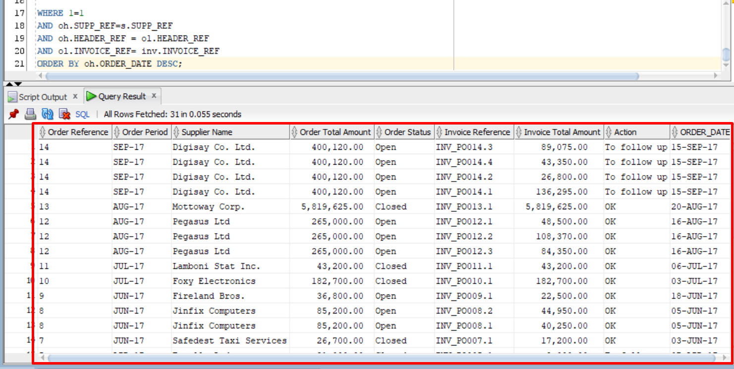



1. Return details for the ***THIRD (3rd) highest Order Total Amount*** from the list. Only one record is expected with the following information. Implement a Stored Procedure or Function to return the required information.

|  |  |
| --- | --- |
| **Column Name** | **Specifications** |
| Order Reference | Exclude prefix PO and return only numeric value, e.g. PO001 shall return value 1. |
| Order Date | Example of expected format “January 01, 2017”. |
| Supplier Name | In upper case. |
| Order Total Amount | Format “99,999,990.00”. |
| Order Status | As per record. |
| Invoice References | For that specific Order, list all invoice references *delimited by comma*. For example., “INV_PO999.1, INV_PO999.2, INV_PO999.3” |

* Script file name: ques5.sql
  + Contains function get_invRef to return concatenated invoice based on order
  + Select statement to return the expected data
* Execution of select statement

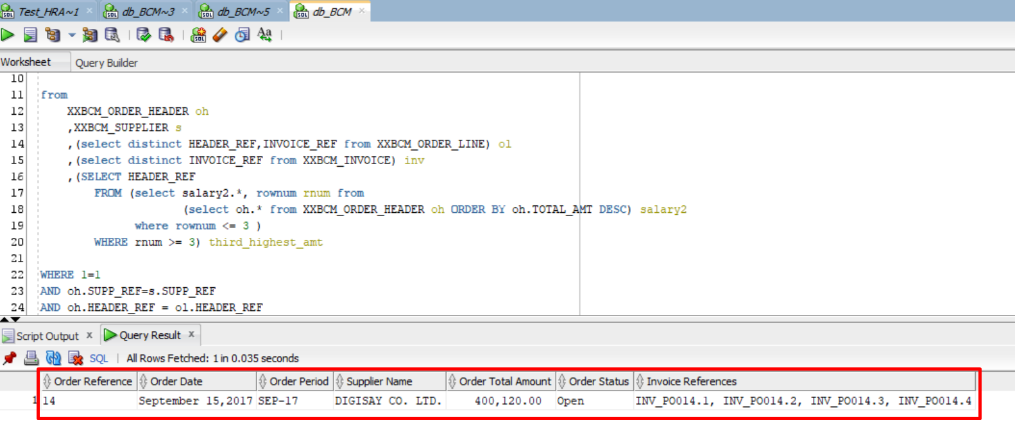



1. List all suppliers with their respective ***number of orders and total amount ordered*** from them between the period of ***01 January 2017 and 31 August 2017***. Output details as per below. Implement a Stored Procedure or Function to return the required information.

|  |  |
| --- | --- |
| **Column Name** | **Specifications** |
| Supplier Name | As per record. |
| Supplier Contact Name | As per record. |
| Supplier Contact No. 1 | First contact number formatted as “999-9999” or “5999-9999”. |
| Supplier Contact No. 2 | Second contact number formatted as “999-9999” or “5999-9999”. |
| Total Orders | Total number of orders. |
| Order Total Amount | Format “99,999,990.00”. |

* Script file name: ques6.sql
  + Contains function format_telNum to return formatted phone number
  + Select statement to return the expected data
* Execution of select statement

